Haemorrhoids are swollen veins in and around the rectum or anus. There are two types of haemorrhoids:
- Internal haemorrhoids. These occur in the veins that are just inside the rectum. They may poke through to the outside and become irritated and painful.
- External haemorrhoids. These occur in the veins that are outside the anus and can be felt as a painful swelling or hard lump near the anus.
Most haemorrhoids do not cause serious problems, and they can be managed with home treatments such as diet and lifestyle changes. If home treatments do not help the symptoms, procedures can be done to shrink or remove the haemorrhoids.
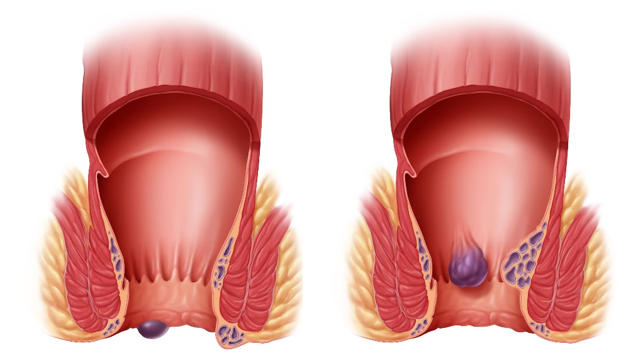
causes
This condition is caused by increased pressure in the anal area. This pressure may result from various things, including:
- Constipation.
- Straining to have a bowel movement.
- Diarrhoea.
- Pregnancy.
- Obesity.
- Sitting for long periods of time.
- Heavy lifting or other activity that causes you to strain.
- Anal sex.
- Riding a bike for a long period of time.
signs or symptoms
Symptoms of this condition include:
- Pain.
- Anal itching or irritation.
- Rectal bleeding.
- Leakage of stool (faeces).
- Anal swelling.
- One or more lumps around the anus.
How is this diagnosed?
This condition can often be diagnosed through a visual examination. Other examinations or tests may also be done, such as:
- An examination that involves feeling the rectal area with a gloved hand (digital rectal examination).
- An examination of the anal canal that is done using a small tube (anoscope).
- A blood test, if you have lost a significant amount of blood.
- A test to look inside the colon using a flexible tube with a camera on the end (sigmoidoscopy or colonoscopy).
How is this treated?
This condition can usually be treated at home. However, various procedures may be done if dietary changes, lifestyle changes, and other home treatments do not help your symptoms. These procedures can help make the haemorrhoids smaller or remove them completely. Some of these procedures involve surgery, and others do not. Common procedures include:
- Rubber band ligation. Rubber bands are placed at the base of the haemorrhoids to cut off their blood supply.
- Sclerotherapy. Medicine is injected into the haemorrhoids to shrink them.
- Infrared coagulation. A type of light energy is used to get rid of the haemorrhoids.
- Haemorrhoidectomy surgery. The haemorrhoids are surgically removed, and the veins that supply them are tied off.
- Stapled haemorrhoidectomy surgery. The surgeon staples the base of the haemorrhoid to the rectal wall.
Follow these selfcare instructions at home:
- Eat foods that have a lot of fibre in them, such as wholegrains, beans, nuts, fruits and vegetables.
- Ask your healthcare provider about taking products that have added fibre (fibre supplements).
- Reduce the amount of fat in your diet. You can do this by eating low-fat dairy products, eating less red meat, and avoiding processed foods.
- Drink enough fluid to keep your urine pale yellow.
- Take warm sitz baths for 20 minutes, 3–4 times a day to ease pain and discomfort. You may do this in a bathtub or using a portable sitz bath that fits over the toilet.
- If directed, apply ice to the affected area. Using ice packs between sitz baths may be helpful.
  - Put ice in a plastic bag.
  - Place a towel between your skin and the bag.
  - Leave the ice on for 20 minutes, 2–3 times a day.
- Take over-the-counter and prescription medicines only as instructed by your healthcare provider.
- Use medicated creams or suppositories as told.
- Get regular exercise. Ask your healthcare provider how much and what kind of exercise is best for you. In general, you should do moderate exercise for at least 30 minutes on most days of the week (150 minutes each week). This can include activities such as walking, cycling, or yoga.
- Go to the bathroom when you have the urge to have a bowel movement. Do not wait.
- Avoid straining to have bowel movements.
- Keep the anal area dry and clean. Use wet toilet paper or moist wipes after a bowel movement.
- Do not sit on the toilet for long periods of time. This increases blood pooling and pain.
- Keep all follow-up appointments as instructed by your healthcare provider. This is important.
Contact a healthcare provider (physician or nurse) if:
- Increasing pain and swelling that are not controlled by treatment or medicine.
- Difficulty having a bowel movement, or you are unable to have a bowel movement.
- Pain or inflammation outside the area of the haemorrhoids.
Get help right away (Emergency call) if:
- Uncontrolled bleeding from your rectum.

