A colonoscopy is a procedure to look at the entire large intestine. This procedure is done using a long, thin, flexible tube that has a camera on the end.
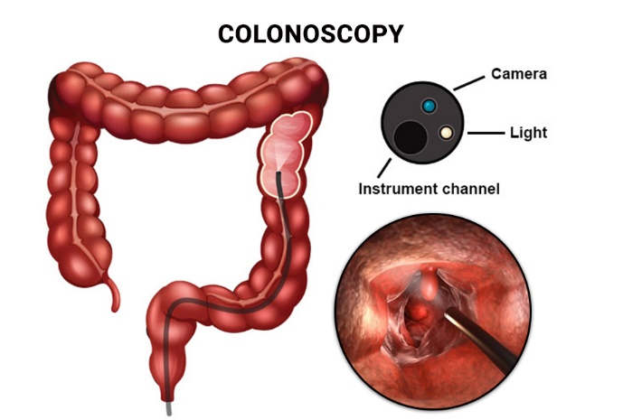
You may have a colonoscopy:
- As part of normal colorectal screening.
- If you have certain symptoms, such as:
  - A low number of red blood cells in your blood (anaemia).
  - Diarrhoea that does not go away.
  - Pain in your abdomen.
  - Blood in your stool.
A colonoscopy can help screen for and diagnose medical problems, including:
- An abnormal growth of cells or tissue (tumour).
- Abnormal growths within the lining of your intestine (polyps).
- Inflammation.
- Areas of bleeding.
Tell your healthcare provider about:
- Any allergies you have.
- All medicines you are taking, including vitamins, herbal medicines, eye drops, creams and over-the-counter medicines.
- Any problems you or family members have had with anaesthetics.
- Any bleeding problems you have.
- Any operations you have had.
- Any medical conditions you have.
- Any problems you have had with having bowel movements.
- Whether you are pregnant or may be pregnant.
risks
Generally, this is a safe procedure. However, problems may occur, including:
- Bleeding.
- Damage to your intestine.
- Allergic reactions to medicines given during the procedure.
- Infection. This is rare.
before the procedure
Eating and drinking restrictions
Follow instructions from your healthcare provider about eating or drinking restrictions, which may include:
- A few days before the procedure:
  - Follow a low-fibre diet.
  - Avoid nuts, seeds, dried fruit, raw fruits, and vegetables.
- 1–3 days before the procedure:
  - Eat only gelatine-based desserts or ice lollies.
  - Drink only clear liquids, such as water, clear juice, clear broth or bouillon, coffee or tea without milk or cream, or clear soft drinks or sports drinks.
  - Avoid liquids that contain red or purple dye.
- The day of the procedure:
  - Do not eat solid foods. You may continue to drink clear liquids until up to 2 hours before the procedure.
  - Do not eat or drink anything starting 2 hours before the procedure, or within the time period that your healthcare provider recommends.
Bowel preparation
If you were prescribed a bowel preparation to take by mouth (orally) to clean out your colon:
- Take it as instructed by your healthcare provider. Starting the day before your procedure, you will need to drink a large amount of liquid medicine. The liquid will cause you to have many bowel movements of loose stool until your stool becomes almost clear or light green.
- If your skin or the opening between the bottom (anus) gets irritated from diarrhoea, you may relieve the irritation using:
  - Wipes with medicine in them, such as adult wet wipes with aloe and vitamin E.
  - A product to soothe skin, such as petroleum jelly.
- If you vomit while drinking the bowel preparation:
  - Take a break for up to 60 minutes.
  - Begin the bowel preparation again.
  - Call your healthcare provider if you keep vomiting or you cannot take the bowel preparation without vomiting.
- To clean out your colon, you may also be given:
  - Laxative medicines. These help you have a bowel movement.
  - Instructions for enema use. An enema is liquid medicine injected into your rectum.
Medicines
Ask your healthcare provider about:
- Changing or stopping your regular medicines or supplements. This is especially important if you are taking iron supplements, diabetes medicines, or blood thinners.
- Taking medicines such as aspirin and NSAIDs. These medicines can thin your blood. Do not take these medicines unless your healthcare provider tells you to take them.
- Taking over-the-counter medicines, vitamins, herbal medicines and other supplements.
General instructions
- Ask your healthcare provider what steps will be taken to help prevent infection. These may include washing skin with an antibacterial soap.
- If you will be going home right after the procedure, plan to have a responsible adult:
  - Take you home from the hospital or clinic. You will not be allowed to drive.
  - Care for you for the time you are told.
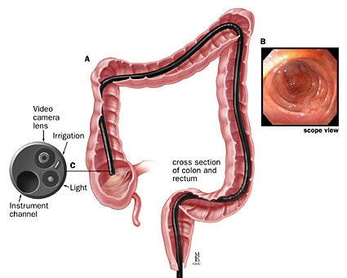
during the procedure
- An IV tube will be inserted into one of your veins.
- You will be given a medicine to make you fall asleep (general anaesthetic).
- You will lie on your side with your knees bent.
- A lubricant will be put on the tube. Then the tube will be:
  - Inserted into your anus.
  - Gently eased through all parts of your large intestine.
- Air will be sent into your colon to keep it open. This may cause some pressure or cramping.
- Images will be taken with the camera and will appear on a screen.
- A small tissue sample may be removed to be looked at under a microscope (biopsy). The tissue may be sent to a lab for testing if any signs of problems are found.
- If small polyps are found, they may be removed and checked for cancer cells.
- When the procedure is finished, the tube will be removed.
The procedure may vary among healthcare providers and hospitals.
After the procedure
- Your blood pressure, heart rate, breathing rate, and blood oxygen level will be monitored until you leave the hospital or clinic.
- You may have a small amount of blood in your stool.
- You may break wind and have mild cramping or bloating in your abdomen. This is caused by the air that was used to open your colon during the examination.
- If you were given a sedative during the procedure, it can affect you for several hours. Do not drive or operate machinery until your healthcare provider says that it is safe.
- It may be up to you to get the results of the procedure. Ask your healthcare provider, or the department that is doing the procedure, when your results will be ready.
Follow these selfcare instructions at home:
- Drink enough fluid to keep your urine pale yellow.
- Follow instructions from your healthcare provider about eating or drinking restrictions.
- Resume your normal diet as instructed by your healthcare provider. Avoid heavy or fried foods that are hard to digest.
- Rest as instructed by your healthcare provider.
- Avoid sitting for a long time without moving. Get up to take short walks every 1–2 hours. This is important to improve blood flow and breathing. Ask for help if you feel weak or unsteady.
- Return to your normal activities as instructed by your healthcare provider. Ask your healthcare provider what activities are safe for you.
- Try walking around when you have cramps or feel bloated.
- If directed, apply heat to your abdomen as instructed by your healthcare provider. Use the heat source that your healthcare provider recommends, such as a moist heat pack or a heat pad.
  - Place a towel between your skin and the heat source.
  - Leave the heat on for 20–30 minutes.
  - Remove the heat if your skin turns bright red. This is especially important if you are unable to feel pain, heat or cold. You have a greater risk of getting burned.
- If you were given a sedative during the procedure, it can affect you for several hours. Do not drive or operate machinery until your healthcare provider says that it is safe.
- For the first 24 hours after the procedure:
  - Do not sign important documents.
  - Do not drink alcohol.
  - Do your regular daily activities at a slower pace than normal.
  - Eat soft foods that are easy to digest.
- Take over-the-counter and prescription medicines only as instructed by your healthcare provider.
- Keep all follow-up appointments. This is important.
- You have blood in your stools 2–3 days after the procedure.
Contact a healthcare provider (physician or nurse) if:
- You have more than a small spotting of blood in your stool.
- You have large blood clots in your stool.
- You have swelling of your abdomen.
- You have nausea or vomiting.
- You have a fever.
- You have increasing pain in your abdomen that is not relieved with medicine.
These symptoms may be an emergency. Get help right away (Emergency call) if:
- Do not wait to see if the symptoms will go away.
- Do not drive yourself to the hospital.

